SOP of Create an AWS Account, Enable MFA
and configure IAM Groups and users

Target: To provide a step-by-step guide for creating an AWS account, enabling multi-factor authentication (MFA) and setting up IAM groups and users to enhance security and manage access permissions effectively.

Prerequisites:
- A valid and unused email address.
- A working phone number.
- A valid Credit or Debit Card
- A smartphone with an authenticator app (e.g., Google Authenticator, Authy) installed.

Procedure:
A. Create a New AWS Account
Step 1: Go to https://aws.amazon.com
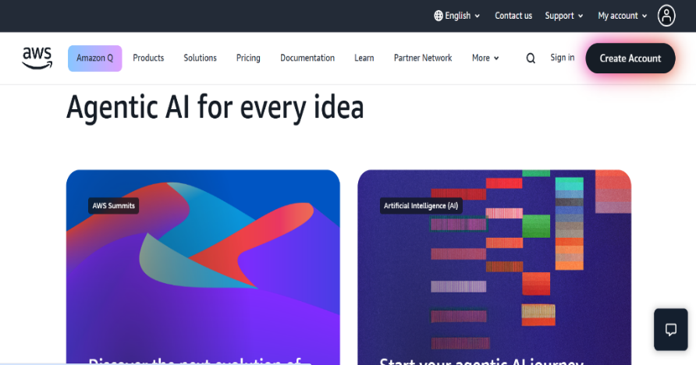

① Click the “Create Account”
①
to begin creating your AWS
account.

Step 2: Fill in the required information: email, password, and account name.
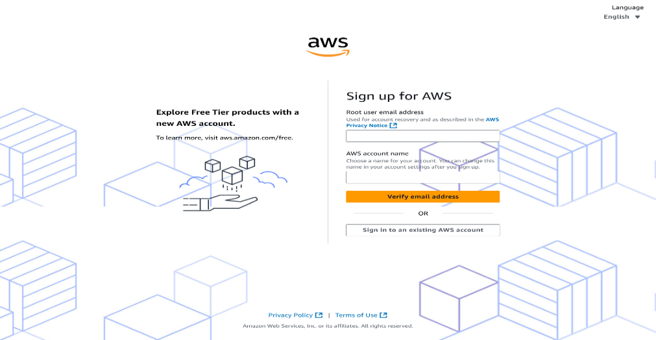
.

Step 3: Choose account type (Personal or Business) and enter personal information.
②

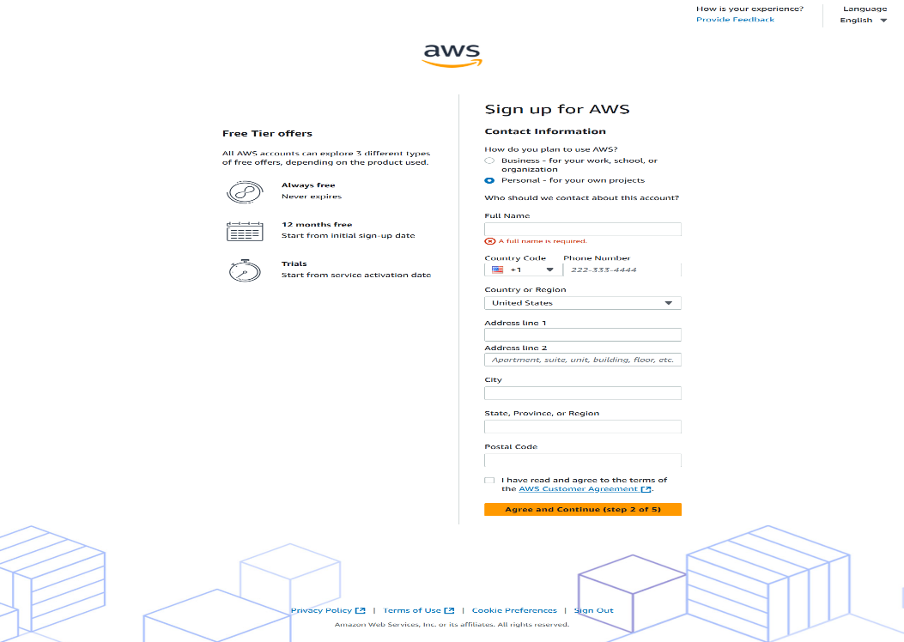
①
① Select “Personal” as the account type. This is recommended for individual use.
② Enter your full legal name, fill in your complete address, including street name, city, and postal code and provide a valid phone number. AWS may use this for identity verification.

Step 4: Enter billing information (Credit/Debit card).
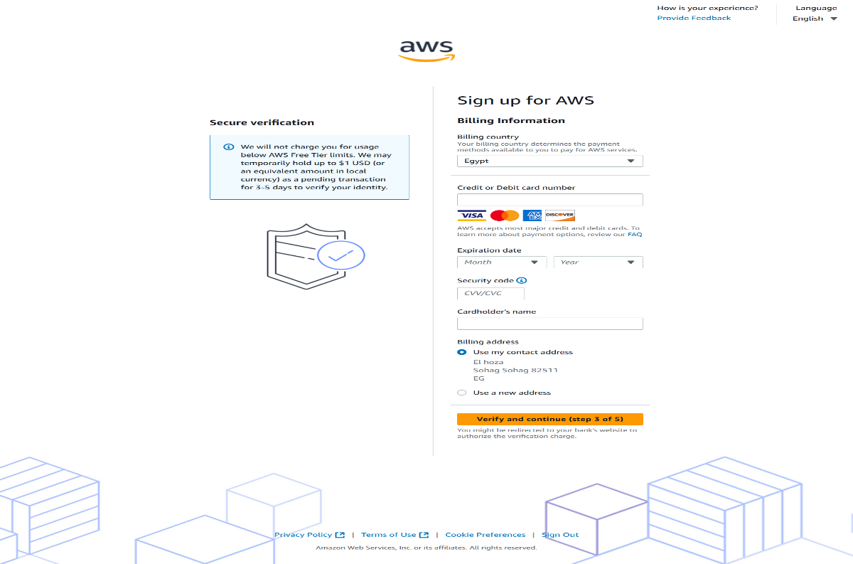
Step 5: Verify your identity via SMS or voice call.
Step 6: Choose the Free Tier Plan (if applicable).
Step 7: Access the AWS Management Console.

B. Enable Multi-Factor Authentication (MFA)
Step 1: Click your account name (top-right corner) → Choose “Security Credentials”.
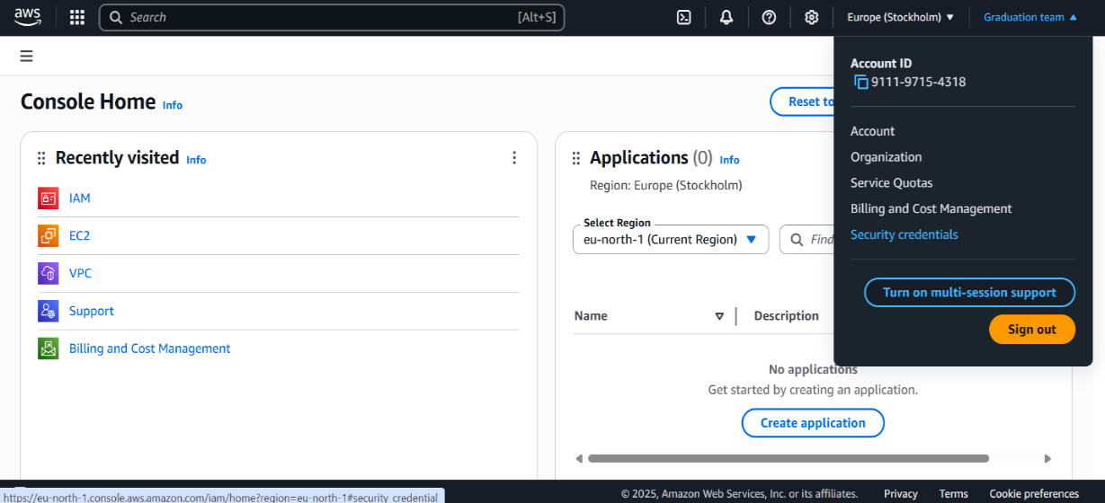

Step 2: Scroll to Multi-Factor Authentication (MFA) section → Click “Assign MFA device ״.
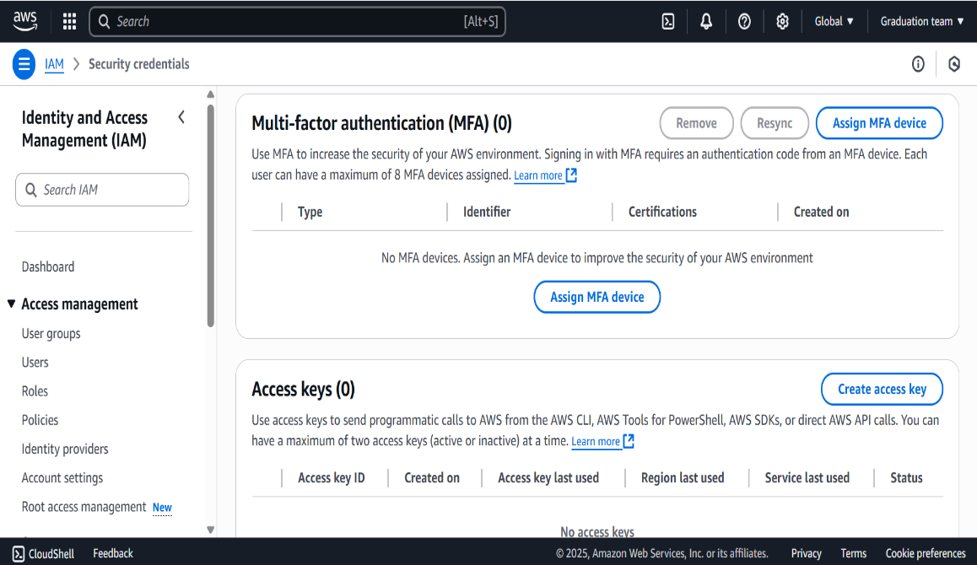

Step 3: Install and select an Authenticator application→ click “Next״.
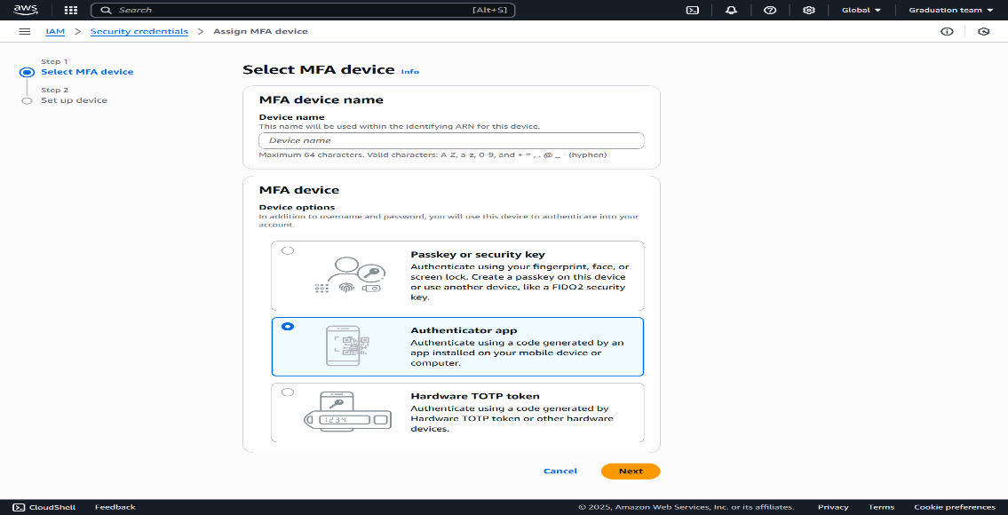

Step 4: Use your authenticator app to scan the QR code shown then enter two consecutive codes from your authenticator app → click “Add MFA״.
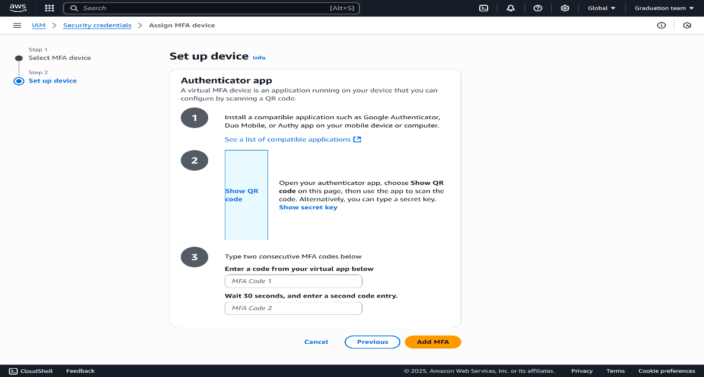
Step 6: Click “Assign MFA” → You will see a success message.

C. Configure IAM Group and Add Users on AWS
Step 1: sign in to AWS console.
①Go to https://aws.amazon.com/console
②Sign in using your root account or an IAM user with admin privileges.

Step 2: Navigate to the IAM Service.
①From the AWS Management Console, in the search bar, type IAM and select it.
②This opens the Identity and Access Management Dashboard.
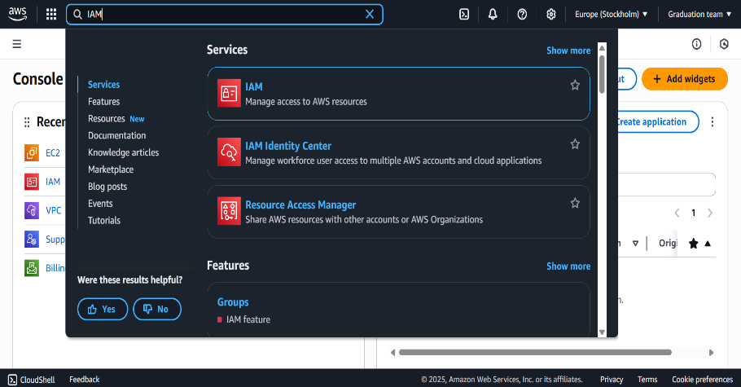
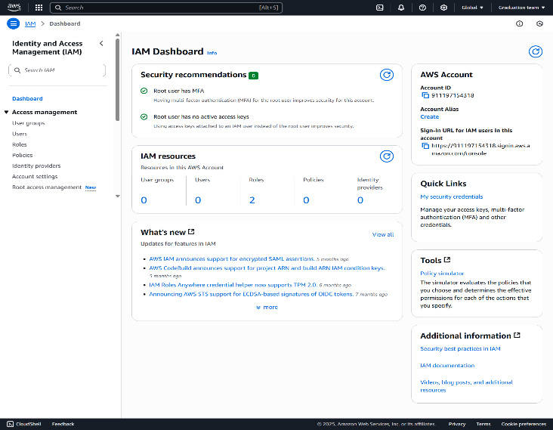
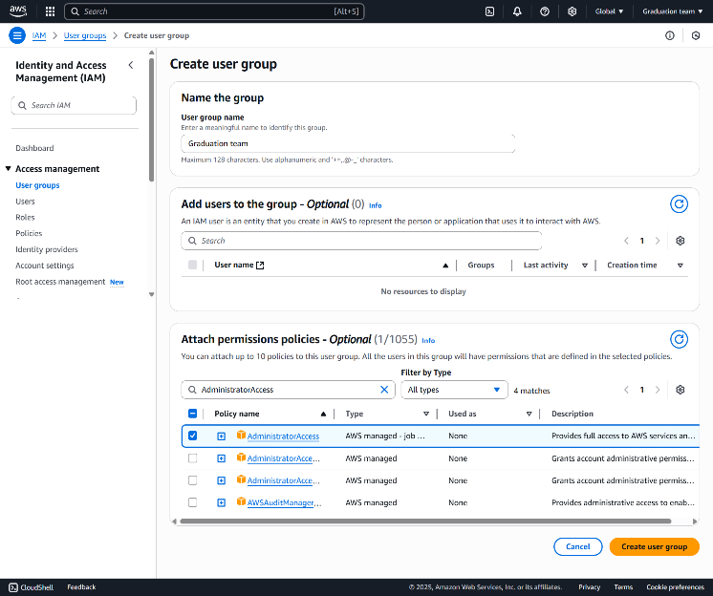
Step 3: Create a New IAM Group.

① in the left menu, click on “user groups”.
② Enter a Group name.
③ on the “Attach permissions policies”, choose an existing policy (e.g., Administrator Access).
④ Click “create user group”.

Step 4: Create IAM Users and Add Them to the Group.
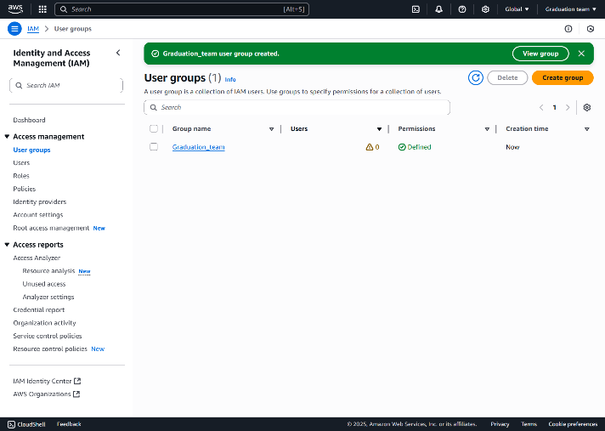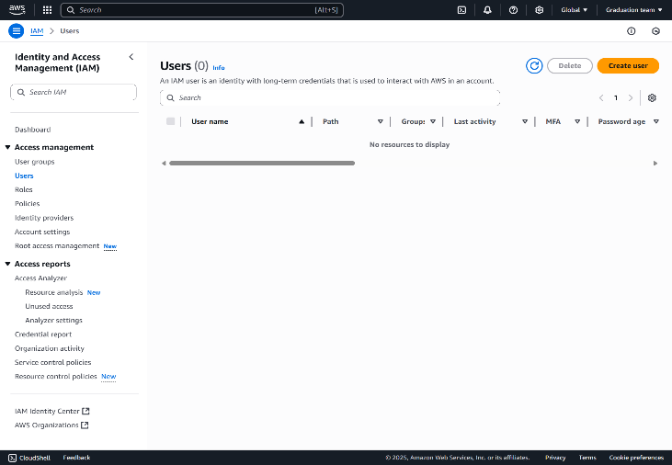
from the left menu, go to users → click “create user”.
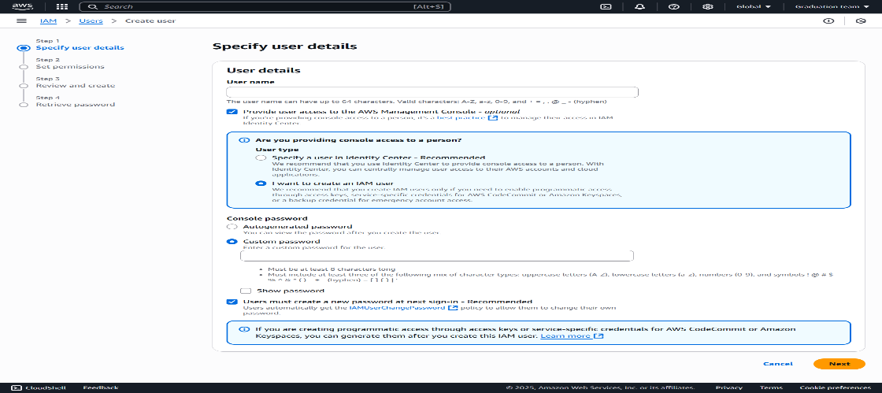
① Enter a username.
② Select “provide user access to the AWS Management Console”.
③ Choose how the password is set, Click “Next”.
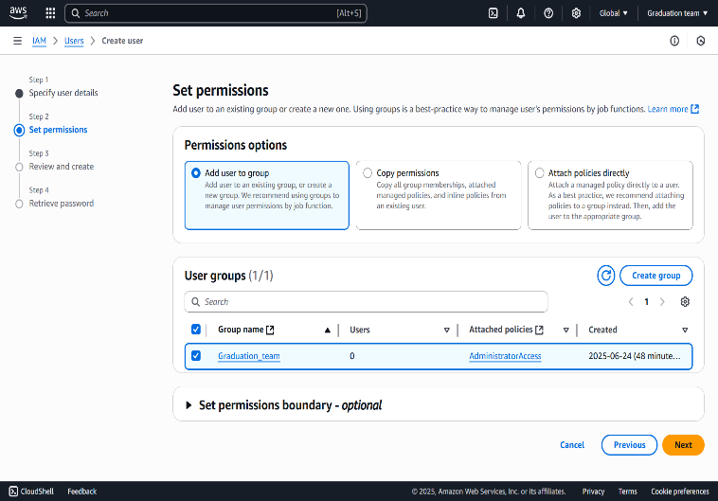

① Click “Add user to group” to set permissions, click “Next” then click “create user”.
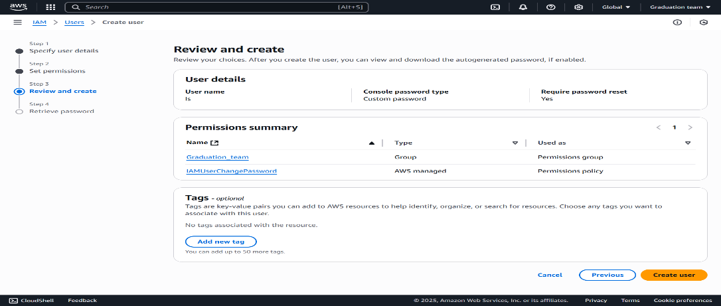
SOP: Create a Virtual Machine (EC2) on AWS

Purpose: To provide standardized steps for launching a Virtual Machine (EC2 instance) on AWS Cloud Platform.
Prerequisites
- An active AWS account.
- IAM user with sufficient permissions (EC2 full access).
- Preferred region selected.
- Basic knowledge of instance specifications (CPU, RAM, Storage).
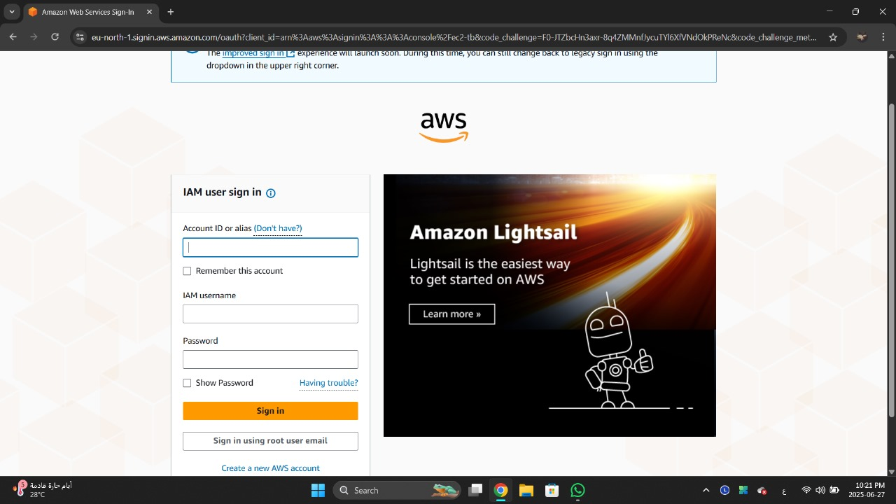
Procedure
1. Log in to AWS Console:
Open: https://eu-north-1.signin.aws.amazon.com/
Sign in with your AWS credentials.

2. Navigate to EC2 Instance:
From the AWS Management Console, go to:
- Services > Compute > EC2
- Or search for “EC2” in the search bar.
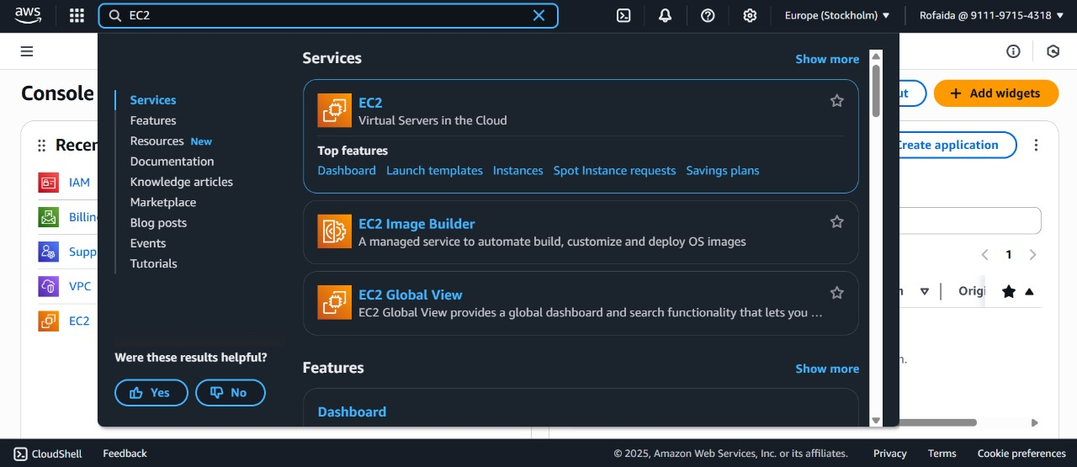
3. Launch an Instance: Click “Launch Instance”.
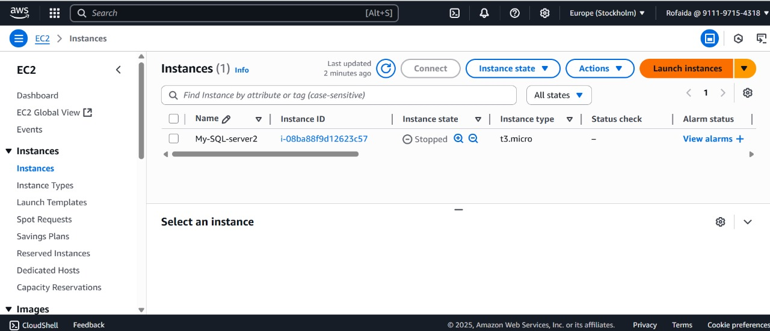

4. Configure Instance Settings:
Field | Configuration
Name | Choose a descriptive name (e.g., web-server-01)
Application and OS Image (AMI) | Select an Amazon Machine Image (e.g., Amazon Linux 2, Ubuntu 22.04, or Windows Server)
Instance Type | Choose based on your use case (e.g., t2. micro for free tier or testing)
Key Pair (Login) | Select an existing key pair or create a new one to enable SSH access
Network Settings | Choose the appropriate VPC/Subnet  Enable firewall rules:  - SSH (port 22) for Linux  - RDP (port 3389) for Windows  - HTTP (port 80) / HTTPS (port 443) if hosting web services
Storage (Elastic Block Store) | Adjust volume size/type (default is usually 8 GiB gp2)
Advanced Settings (optional) | Add user data scripts, monitoring, etc.
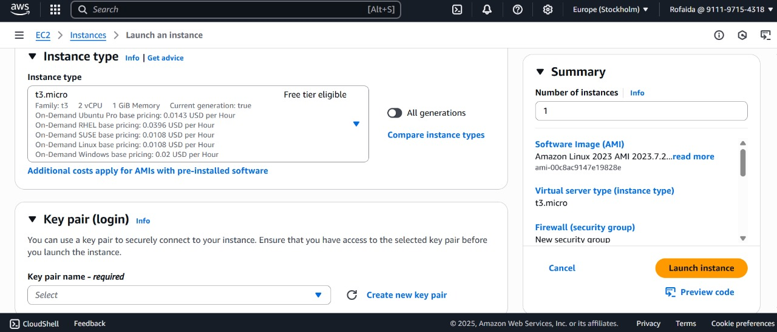
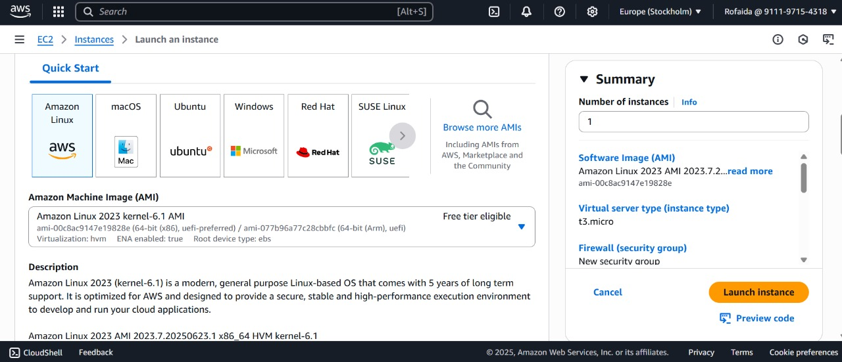
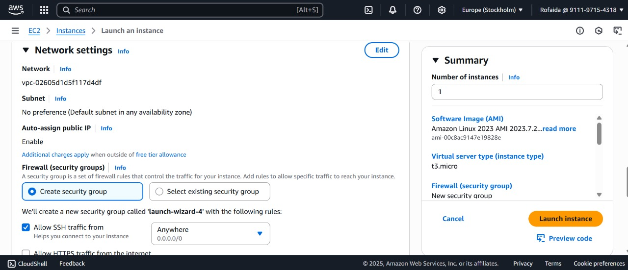

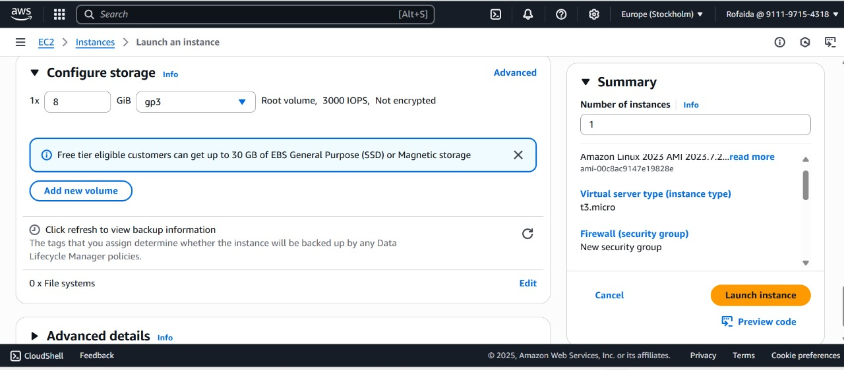
5. Review and Launch:
- Double-check your configuration.
- Click “Launch Instance”.
- Wait a few seconds while AWS provisions your VM.

6. Connect to Your Instance:
- Go back to the EC2 dashboard.
- Click on your new instance.
- Press “Connect” and follow the method:
  - SSH (for Linux):
- Use the key pair with terminal:
- ssh -i /path/to/your-key.pem ec2-user@<public-ip>
  - RDP (for Windows):
- Download the remote desktop file and login with the password from your key.

Post-Deployment Checks:

- Test connectivity (ping/SSH/RDP).
- Verify your application or service is running.
- Ensure the instance has proper security groups.

Notes & Best Practices:

- Always use strong key pairs and restrict access by IP.
- Stop or terminate instances when not in use to avoid charges.
- Regularly monitor CPU, memory, and network usage from EC2 dashboard.
- EC2 Configuration and VM Integration using SSH, Telnet& Stelnet.

-----------------------------------------------------------------------------------------

EC2 Configuration and VM Integration using SSH, Telnet, and Stelnet
steps for setting up an EC2 instance running Red Hat Enterprise Linux on AWS, and integrating it with a local virtual machine (VM) using SSH, Telnet, and Stelnet protocols.
1. Launching EC2 Instance with Red Hat
Accessed AWS Management Console and selected EC2 service.
From the Launch Instance option, the following configurations were applied:
- Name: RedHat-Server
- AMI: Red Hat Enterprise Linux
- Instance Type: t2. micro
- Key Pair: A new PEM key pair was created and named mykey.pem security
Group rules were configured to allow:
SSH (Port 22), Telnet (Port 23), Custom TCP port (e.g., 6000) for Stelnet simulation
The instance was successfully launched.

2. Connecting EC2 with Local VM

- The public IP address of the EC2 instance was retrieved.
- Ping test was performed from the local VM to verify connectivity.
- Network settings and security group permissions were verified to ensure access.

3. SSH Configuration
- The mykey.pem file was placed in a secure directory.
File permissions were set to read-only using: chmod 400 mykey.pem
- SSH connection to the EC2 instance was established using: ssh -i mykey.pem ec2-user@<Public-IP>
- The connection was confirmed successful using SSH protocol.
- SSH allows secure authentication using a private key with the default Red Hat user (ec2-user).

4. Telnet Configuration on EC2

- Required packages were installed: sudo yum install telnet-server xinetd -y
- The xinetd service was enabled and started: sudo systemctl enable xinetd
sudo systemctl start xinetd
- The configuration file /etc/xinetd.d/telnet was modified: disable = yes → disable = no
- The service was restarted: sudo systemctl restart xinetd
- Port 23 was opened in the firewall: sudo firewall-cmd --permanent --add-port=23/tcp
sudo firewall-cmd –reload

5. Stelnet Simulation using SSH on Custom Port
- Stelnet is not natively available on Linux, so SSH was used on an alternative port (e.g., 6000) as a substitute.
- The SSH configuration file was duplicated: sudo cp /etc/ssh/sshd_config /etc/ssh/sshd_config_stelnet
- The new file was modified to include: Port 6000
- A new SSH daemon instance was started with the modified file:
sudo /usr/sbin/sshd -f /etc/ssh/sshd_config_stelnet
- Port 6000 was opened in the firewall: sudo firewall-cmd --permanent --add-port=6000/tcp
sudo firewall-cmd –reload
- The connection was tested from the VM using: ssh -i mykey.pem -p 6000 ec2-user@<Public-IP>
- SSH over port 6000 successfully simulated the Stelnet protocol.
An EC2 instance running Red Hat was successfully configured and connected to a local VM using SSH, Telnet service was enabled and tested, and a Stelnet equivalent was simulated using SSH on a custom port.

